**Our Lady of the Assumption Catholic Primary School,**



Common Edge Road, Blackpool FY4 5DF

# Tel: 01253 762833 Fax: 01253 312583

email : admin@our-lady.blackpool.sch.uk

18th October 2019

Dear Parents/Carers,

On Thursday 31st October Our Lady’s will be celebrating Maths Day; a day packed with exciting and engaging maths challenges! On this day your child will have the opportunity to experience lots of different types of maths investigations and take part in fun and thought-provoking mathematical challenges. It is a fantastic opportunity in school for us to give over a whole day to Maths and all the wonder that the subject brings.

As part of our celebration we would like the children to come to school that day inspired by Maths and dressed for the occasion! This may mean that your child comes to school dressed as a famous mathematician such as Newton or Einstein or comes dressed as their favourite shape or number, or simply in a t-shirt covered with numbers. The choices are endless…maybe these pictures will give you a few ideas!

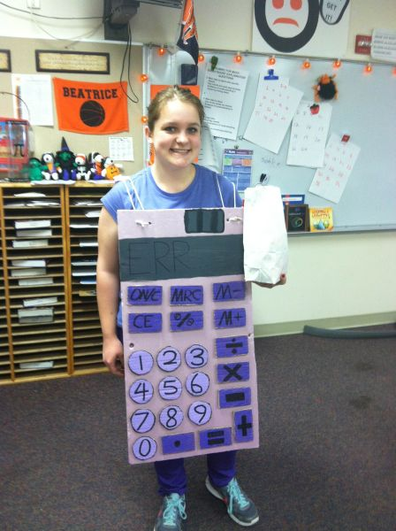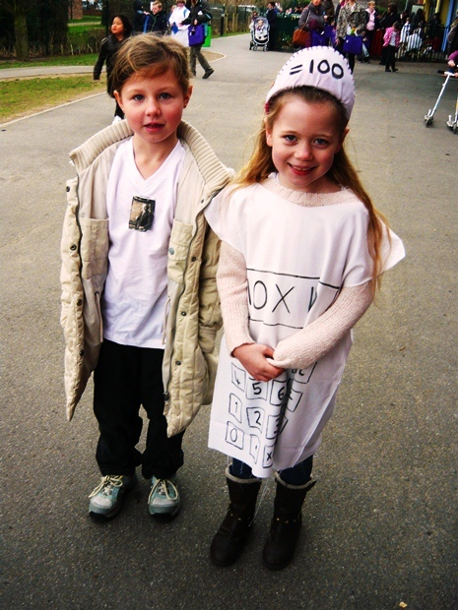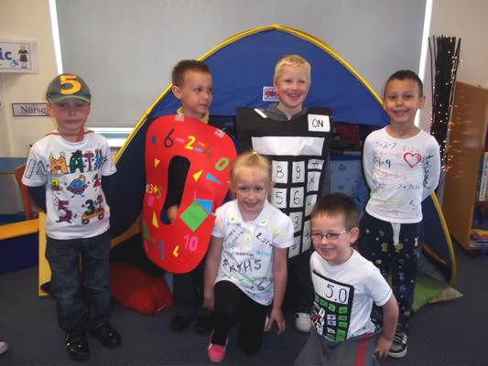

Here at Our Lady’s we value the great skills that mathematical fluency brings to our children and by celebrating Maths Day we hope to make maths come alive. We are very excited by this day and we hope that you will support us by helping your child to create a costume to remember.

Thank-you for your support

Mrs Hollinghurst

Maths Co-ordinator