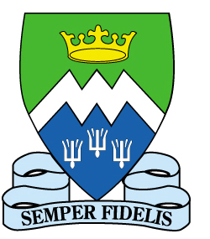St Mary’s Catholic Academy
St Walburga’s Road
Blackpool FY3 7EQ
Tel: 01253 396286
Fax: 01253 442583
E-mail: admin@st-mary.blackpool.sch.uk Headteacher: Mr S Eccles BSc (Hons), MEd
9 September 2015

Dear Parents

Over the coming months you will have to make the very important decision about which secondary school to send your child to in September 2016. To help you with your decision Our Lady of Assumption and St. Mary’s are holding a joint meeting for parents on Monday 21st September 2015 starting at 6p.m. at Our Lady of Assumption.

At the event there will be a series of short talks from senior staff at St. Mary’s, the opportunity to ask questions and the chance to find out in more detail some aspects of the work done by our local Catholic Academy. With a strong track record in examination results, a strong pastoral system and our most recent inspections grading the College as good with many outstanding features (Ofsted) and outstanding for the third consecutive time (Lancaster Diocese) we hope we have an education to offer your child that may be of interest to you.
The Open Evening at St. Mary’s will be on Monday 28th September 2015 with parents from Our Lady of Assumption invited to attend the evening at 6:30 p.m. There will be tours of the College to see the new facilities, talk to our staff and students and see the students at work.

As headteachers we believe that working in partnership with each other to support parents and children in making this critical decision is vitally important. We hope you will be able to attend the event and look forward to seeing you there.

Yours sincerely,

M.Haggerty

Miss Haggerty Mr Eccles
Headteacher Headteacher
Our Lady of Assumption Catholic Primary School St Mary’s Catholic Academy

